A limited quantity of 420 boats will be available for the 2016 New Zealand Nationals, Kohimarama Yacht Club, Auckland on a first booked basis.

Vendor owned supplied boats will be Blue Blues and Ziegelmayer hulls. Sails will be used Norths or Olimpic.

Each boat for charter will be equipped as follows:
Equipment item Damage | Comments
- one hull, including 1 mainsheet block
- one towrope
- one set of toestraps
- one rudder
- one rudder lock pin and rudder pin control line
- one centre broad (in place)
- one centre board control line
- one wind indicator
- aluminum beach trolley
- One used Main
- One used Jib
- One used Spinnaker
- 1 x set Spinnaker sheets
- 1 x set Jib sheets
- 1 x main sheet
- 1 x vang with connector to mast
- 1 down haul
- 1 topping lift
- 1 spinnaker pole with release line
- 1 spinnaker halyard
- 1 main halyard
- 1 jib halyard and tension equipment with S hook
- 1 tiller extension and tiller
- 1 set of trapeze wires
- 1 x mast
- 1 x boom with installed outhaul
- 1 set mylar
- 1 set of bungs
- 3 inspection caps
- 1 main sheet traveler set with pulley

The charter/sales price may include other non-listed equipment with the boat.

Competitors may bring or use their own foils and spars or sails.

Competitors shall not modify the supplied boat and/or equipment or cause them to be modified in any way except that:

- a compass may be tied or taped to the hull.
- hulls, centerboards and rudders may be cleaned, but only with water.
- adhesive tape may be used anywhere above the waterline.
- all fittings or equipment designed to be adjusted may be adjusted, provided that the Class Rules are complied with.
- use of marker pens on hulls is NOT permitted. Sail numbers to be written on tape.
- any stickers or tape that has been applied to the boat should be removed before the boat is returned.
- Sanding of any part of the hull or foils is not permitted.

Charter period will be from 1th March to 13th March 2016 inclusive at a cost of NZ$700. Full cash payment is required on booking to confirm charter.

Early arrivals may be able to gain access to charter boats for the purpose of set up and practice by prior arrangement or at the discretion of the Vendor.

Note: Charter fees are non refundable.

In addition to the charter fee, a damage deposit of NZ$450 (cash) will be required on receipt of each boat, to be fully refunded if no damage has occurred.

Boats and equipment must be returned washed and with all equipment replaced as supplied.

Public Liability Insurance is the responsibility of the Charterer.

The boats will be available for sale at the end of the Regatta.

To book your charter boat please complete the attached form and return to:

Email: richard.cave@xtra.co.nz

420 CHARTER to buy BOOKING FORM

Agreement between

Boat Owner: ___________________________________mobile: ___________________

email: __________________________________________

and

Charter: ________________________________ mobile: _________________________

email: ________________________

Agreement Date: ______/ ____/2016

Please complete & return to: Email: richard.cave@xtra.co.nz

Regatta: 2016 NZ 420 Nationals, Kohimarama Yacht Club, Auckland

Date: 1 Jan – 20th March 2016 Regatta Charter Fee: $700
(Deductible from the purchase price)

Pre agreed Purchase Price: ______________

Pricing owing (Purchase price less charter fee): _______________

Payment terms: ___________________________________________

Charter name:

Sailing Club:

Parent name:

Address:

Postal Code:

Ph No:

Ph No: Email:

Planned Skipper:__________________ Planned Crew:_______________

Refundable Damage/loss Deposit: NZ$450 (pay by cash when boat picked up)
Insurance is the responsibility of the hirer as is the full cost of the repair of any damage or replacement of lost equipment

Cash Payment method confirmed paid by: signed:

☐ Please tick and initial that you have 3rd party Insurance. _______

☐ Initial Damage deposit of $450 cash paid. (Refundable) ____________

I agree that I am liable for any damage that is made to the boat or any other equipment that I have chartered from _________________________ throughout the following period of time 1 January 2016 to 20 March 2016. I will return the Hull (including all fittings) Trailer, Foils (rudder and center board), and spars in the same condition that I received them in, if there is a problem or equipment becomes damaged it is my responsibility to inform ______________________ on mobile ___________ to organise a replacement or repair. I also agree that any scratch ding or crash will be covered at my responsibility of cost. The Vendor will charge $10 every scratch in the boats hull. I concur that neither the Nationals Regatta organizing authority or the NZ 420 Association are parties to the agreement in aby way whatsoever. I agree that Mike Pierce Boat builders will be contracted to repair any damage. I agree not to hold the YNZ High performance sailor responsible for any damage. By signing this contract I confirm that I agree to the above conditions.

Pre exiting damage marks indicators (x)
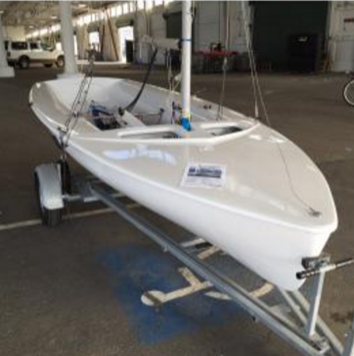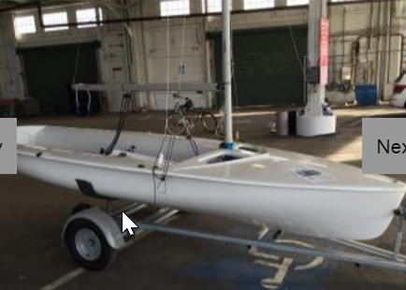

List of marks / preexisting damage list

Pre existing damage Verification Witnessed by: _____________________

Signature: __________________________

Lessees Signature:
Office use only:

Boat returned: Loss / Damage / No Damage

Details:

