Amendment 1 - Regatta Specific Schedule

Course illustration update

Nacra Mark 1a is removed and replaced with Nacra Mark 1A.
Nacra Course description has changed for LA4.

Steve Pyatt
National Race Officer
Kohimarama Yacht Club
09 March 2016

Amendment One
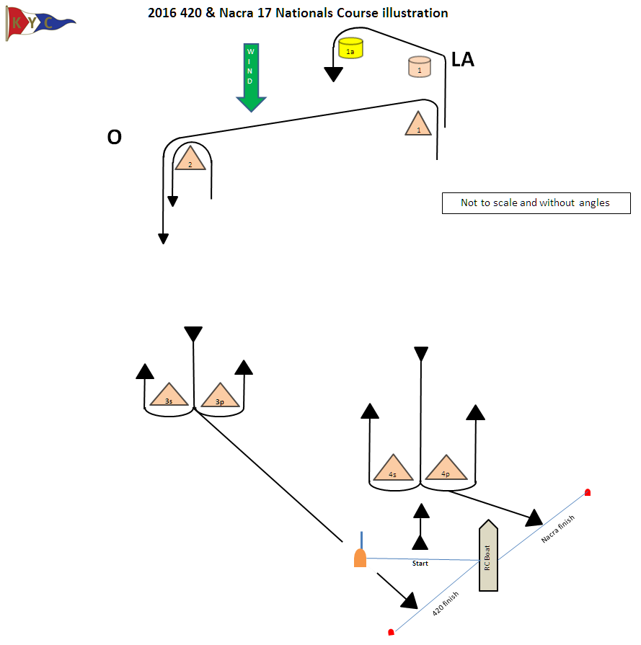
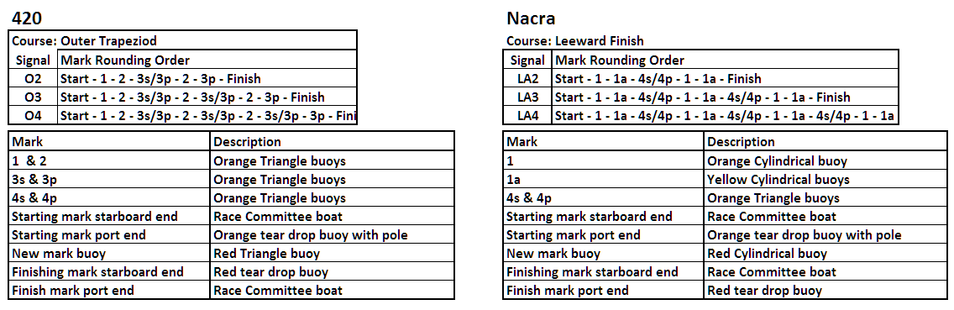

1A

